Prescribing
Key points to remember for prescribers
Before starting to write
- Correct patient
- Correct address – some may have moved house but have old stickers in notes
- Correct medication item – e.g. when on more than one formulation of methylphenidate
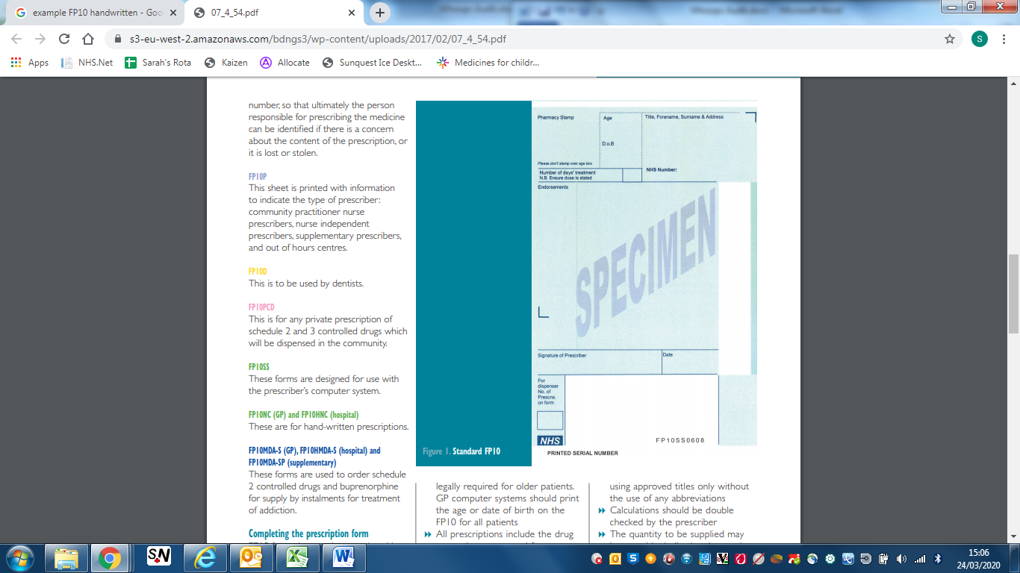
- Correct formulation – e.g. when available in more than one form
DON’T write in the white column at the right hand side OR green endorsements areas
Finishing off
- Sign
- Print (or use stamp)
- Date
Demographics:
- No sticky labels
- Ensure current address
- Don’t forget Date of Birth
- No amendments (or make very clear if needed)
Melatonin
- Check preferred formulation (liquid v tablets)
- For liquid check alcohol free / not – Avoid brand names as may be unavailable
- For tablets – check available strengths
  - Circadin = 2mg (packs of 30)
  - Slenyto = 1mg (pack of 60) or 5mg (pack of 30)

Methylphenidate
- Check which preparation patient needs – standard or modified release & formulation
  - Medikinet Immediate release tablets
= 5mg, 10mg, 20mg (all pack of 30)
  - Medikinet XL capsules
= 5mg, 10mg, 20mg, 30mg, 40mg, 50mg, 60mg (all packs of 30 capsules)
- Words AND figures
  - e.g. please supply 60 (sixty) x 10mg (ten milligram) capsules
- Beware when prescribing more than one strength (e.g. to achieve 15mg) to match correct words and figures

Prescribing controlled drugs

Controlled drugs subject to prescription requirements are all preparations in schedule 2 and 3. These drugs can be identified by the following symbols in the BNFc:
for preparations in schedule 2
for preparations in schedule 3

The following are requirements for prescriptions of controlled drugs:
- Indelible ink must be used
- Prescriber must sign the prescription – whether the prescription is handwritten or printed
- The date the prescription was signed must be recorded
- Prescribers address must be specified (and must be within the UK)

The following details must be included:
- The name and address of the patient (PO box addresses are not acceptable)
- Medication details:
  - the form (e.g. tablets, liquid)
  - the strength
  - the dose
  - to avoid ambiguity where the prescription requests multiple strengths of medicine each drug should be prescribed separately (i.e. separate dose, total quantity)
- Supply:
  - Total quantity to be supplied in words and figures of dosage units to be prescribed

Other information:
- Prescriptions for controlled drugs are valid for 28 days from the date stated
- Alterations to the prescription are best avoided but if made, cross out the error, initial and date it then write the correction
- If an error is made that can’t be corrected put a line through the prescription and write spoiled or destroy it.

The most commonly prescribed controlled drugs in community paediatrics are stimulant medications for ADHD.
Examples:
1. For methylphenidate hydrochloride 15mg PO OM prescribe:
Methylphenidate hydrochloride 5mg tablets
Take one tablet PO OM
Supply 30 (thirty) tablets
AND
Methylphenidate hydrochloride 10mg tablets
Take one tablet PO OM
Supply 30 (thirty) tablets
To have a total of 15mg (5mg + 10mg) methylphenidate each morning

2. For Equasym XL 20mg PO OM prescribe:
Equasym XL 20mg capsules
Take one capsule PO OM
Supply 30 (thirty) capsules

